Monitoring and Securing the DFI Environment Introduction

Project Overview
Douglas Financials Inc (DFI from here forward) has experienced successful growth and, as a result, is ready to add a Security Analyst position. Previously, Information Security responsibilities fell on our System Administration team. Due to compliance and the growth of DFI, we are happy to bring you on as our first InfoSec employee! Once you are settled in and finished orientation, we have your first 2-Weeks assignments ready.
Your first set of tasks is to analyze Windows servers using Defense in Depth principles and the concept of Least Privilege and provide a report of any recommendations on OS hardening, compliance issues, encryption, and network security.
You'll next be asked to recommend mitigation steps from your analysis of firewall reports (and new connections) in the form of creating sample firewall rules. Similarly, you'll analyze threat intelligence and craft sample IDS signatures. You'll also encrypt several files and folders in preparation for transport to a client.
In the above image, you can see two of the documents you will see while completing the project. The document template(opens in a new tab) (Cyber Track Cubs Project Starter Template) contains all of the instructions as a place for your answers to submit for assessment. The second document is part of a threat report that you will be provided to make recommendations to mitigate threats.
You will complete some activities in the VMs provided, but provide your answers or evidence in the template above.
Some activities will be more difficult than others, but take your time, and you'll do great!

Environment
LessonDownloads
Here is the VM inside which you'll work for this project. This machine has the necessary configuration required for the project steps.
Udacity Cloud Labs
Udacity Cloud Labs are the Virtual machines made available to you on the pages labeled "Cloud Lab - <VM_Name>." See the screenshot of the following Cloud Lab below:
- CYBERND0201 "Windows Server 2016" machine - The is the machine where you will perform all the project tasks.
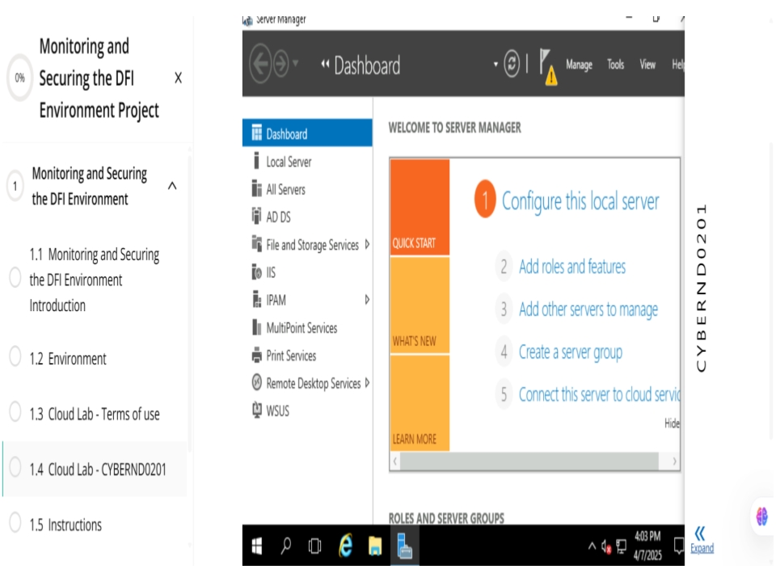
Cloud Lab - CYBERND0201 "Windows Server 2016" machine

Start the Cloud Lab VM
- Click on the ACCESS LAB button. Wait until the Cloud Lab loads (this could take up to 5 minutes).
- You can use the Cloud Lab VM either in the classroom or use the generated RDP/SSH credentials to connect from your local machine.
- To find the RDP credentials, go to the Lab Environment tab to get Azure login credentials and RDP/SSH credentails.
  - For connecting to Windows machines, you will get Remote Desktop Connection credentials.
  - Tip: Access the Windows Cloud Labs from an incognito browser to have a seamless experience.

Restrictions
- Cloud Labs' session time is limited. Your session will expire after the validity expires, and you will lose all your resources in the temporary Azure account.
- You have limited 10 attempts for each Cloud Lab. Refer to the Cloud Lab Terms of Use page next for more details.
- Later, when you come back or refresh the Cloud lab page, you will get a new VM with a new pair of temporary credentials.

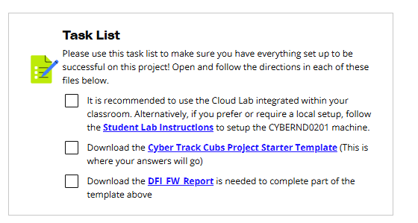

Cloud Lab - Terms of use
LessonDownloads

Terms of Use
- This cloud lab is a sandbox environment and thus has a limited session duration. After the session expires, the learner will have to reload the lab page and start a new session, which will be counted as the second attempt.
- Click on the Access Lab button at the bottom of the current page to load the Cloud lab, and it will take up to 5 mins to boot a Virtual Machine and configure it for the exercises.
- Udacity does not preserve Azure resources across sessions. After the session expires, any resources you have created (VMs, Databases, Web Apps and their files, etc.) will be deleted.
- There are only 10 attempts permitted for this lab throughout the course. Therefore, we strongly recommend that learners only access the lab when necessary. After exhausting all attempts, learners will encounter the Usage limit is crossed error, which a learner can resolve by writing an email to "udacity-labsupport@udacity.com(opens in a new tab)".
- There are certain restrictions we've set up in the cloud lab. Refer to the Cloud Lab - Overview and Restrictions page to know more.
- Please follow the instructions described in the exercise/project instructions. Udacity monitors lab usage to ensure the proper use of resources for educational purposes.
- As Udacity pays for every minute of runtime, please stop the environment when you take a break. Always delete the resources if not in use.
- Misusing the lab resources can cause revoking your lab access or deactivation of your Udacity account.

Getting Help

Lab loading issues
If you have a problem while loading your cloud lab or permission issues in Azure, you can send an email, titled Error in Lab, to Udacity Support at (opens in a new tab)udacity-labsupport@udacity.com(opens in a new tab). Please be sure to send your message from the email ID you used to enroll in the Nanodegree program. Please include the following information in your email body:
- Course name
- Lesson name
- Page name
- Steps to replicate the issue
- Error screenshots
Note that the "udacity-labsupport@udacity.com(opens in a new tab)" email is dedicated only to Azure cloud lab support, such as lab loading issues, Azure policy issues, or increasing the retake count. DO NOT email this team for content-related problems. Instead, file a support ticket for content-related issues.

Self help resources
- Review the Udacity FAQ(opens in a new tab) - Your question may have already been answered! Search through our FAQ first.
- Submit a question via Knowledge Hub(opens in a new tab) - Knowledge Hub is where you can ask questions specific to the course or Nanodegree you’re enrolled in. This is mainly to get that one on one feedback from mentors in a way similar to the real world using Stack Overflow.

Submit a support ticket
If you have a classroom content-related issue blocking your progress, you can submit a support ticket to escalate to the correct Udacity team. You can find the link to file a support ticket(opens in a new tab) in your classroom home.
For other blocking issues, you can write to us at support@udacity.com

Instructions
LessonDownloads

Project Instructions

Project Steps Overview
To complete this project, you will need to complete the following:
- Download from the Project Resources:
  - Cyber Track Cubs Project Starter Template(opens in a new tab)
  - DFI FW Report(opens in a new tab) - Firewall Report Document
- Login to the CYBERND0201 Windows Server 2016 machine provided in the cloud lab.
- In the system provided, analyze using Defense in Depth, Principles of least privilege, NIST 800, and Microsoft best practices (links provided.)
- Recommend 2 firewall rules for new vendor connections (information provided.)
- Recommend encryption in transit for new vendor connections.
- Create at least one IDS rule based on the intelligence provided.
- Ensure executables received from vendors are legitimate by comparing file hash with known good copy.
- Recommend areas that could be improved using automation.
- Create a report detailing successful and unsuccessful connection attempts using PowerShell to view event logs (2 incidents required).
- Using NIST 800 and Microsoft Best Practices, recommend which updates should be installed and which could be left off.
- Provide mitigation response to firewall alert report. (Sample data provided.)
- Encrypt data files and folders for delivery to the vendor.
- Ensure that you have met all of the requirements of the Project Rubric.

Project Details
After downloading the templates:
- Rename the templates with your name in them. Example: Peyton Smith Monitoring and Securing the DFI Environment
- The Project Template has detailed instructions as to what to complete for each step of our project. You should complete your work inside of this template and submit the template when you have completed the project.
- Where the project asks for justification or rationale, please be thorough in your explanations and provide answers that a non-technical stakeholder would understand.

Submission Instructions
After completing the project:
- Confirm that you have met all of the requirements in the Project Rubric.
- Compress the PDF or Word Document report into a ZIP file with a password.
- Create an empty folder named Defending and Securing Systems Project. Copy/paste the compressed zip file into this folder.
- Compress the Defending and Securing Systems Project folder into a zip file. Do not set a password for the zipped folder.
- Submit the zipped Defending and Securing Systems Project folder on the Project Submission page. Note that our system will not accept a folder upload, only a zip file containing that folder.
Important:
- You are required to encrypt the subfolder within your project report before zipping the file. The final .zip file itself should remain unencrypted. When you submit your project, don't forget to add the password to the Submission Details. If no password is shared, the reviewer will not be able to assess and review your project.
- If you receive an error message when submitting your project, please ensure that only the subfolder within your project report is encrypted before zipping. The final .zip file itself should not be encrypted.

Rubric
Use this project rubric to understand and assess the project criteria.

Connecting, Reporting and Analysis
Criteria | Submission Requirements
The student will demonstrate the ability to successfully login to the Windows Server machine. | - Provide a screenshot showing the login status to the CYBERND0201, Windows Server machine.
The student will demonstrate an understanding of the NIST Framework, Defense-in-Depth and documentation from Microsoft by performing an analysis of the security configuration on the servers provided. | - A report detailing 3 primary areas  - File Permissions that need modified  - Roles that are not needed on Windows server  - Any services that should or should not be running
The student will demonstrate an understanding of the appropriate encryption for data in transit. | - Choose one of the appropriate encryption methods from the documentation provided. Provide justification for the method you chose.
Automation is only discussed, not implemented. The students will be able to recommend at a very high level what should be automated and how. | - In report or table form, provide 3 areas where automation could be deployed to DFI.  - Example: Area: Active Directory. The item for automation: Automatic account lockout if login from 2 geographically distant IPs.
Understanding the needs of the organization (vis-a-vis the server configuration) with what is needed via NIST 800-43 and Microsoft's Security Update Guide the student will select the appropriate updates for install. | - The student will provide a table that lists at least 3 updates that should be installed and 3 updates that are not necessary.  - Justify your recommendations as to why you are making your choices.

Firewalls and IDS Configuration
Criteria | Submission Requirements
The students will demonstrate a basic understanding of firewall concepts and how to craft a simple firewall rule. | - Provide the commands necessary to complete the firewall rule given the scenario in the template.
The students will demonstrate a basic understanding of IDS concepts and how to craft simple IDS rules. | - Provide the commands necessary to complete both of the scenarios given in the template.  - For documentation purposes, explain your commands for non-technical management.
Students will demonstrate a basic understanding of how to appropriately mitigate a threat via firewall alerts. | - The student will provide mitigation recommendations based on their analysis of the report with a focus on friend/foe of the source IP as well as an additional layer of protection for the destination IP.

Encryption, and Hashes
Criteria | Submission Requirements
Students will demonstrate the ability to ensure executables are legitimate by comparing file hash with a known good copy or with a hash provided in advance. | - Provide a screenshot that displays the command that was run as well as the file hash.
Students will demonstrate an understanding of how to log certain events, in this case, failed RDP attempts. | - Export the results to CSV on the server provided.  - Open the CSV with notepad.  - Provide a screenshot of the results
Students will produce a narrative 'status report' that will tie all of the projects together in the form of a report to management. | - Explain all of the tasks performed in the first two weeks.  - Explain any recommendations for changes in permissions.  - Tie all of the work done together in a big picture narrative.  - Recommend the way forward for DFI in terms of security products (at least 2) and policies (also at least 2.)
Demonstrate encrypting a directory. | - Encrypt the deliverables in the previous steps using 7zip and a strong password.  - Upload the file to Udacity for testing.  - Provide the password to the file in the notes to the reviewer.

Suggestions to Make Your Project Stand Out
- When recommending automations, expand your recommendations beyond the areas explicitly listed.
- When reviewing Windows permissions suggest ways to streamline and centralize the ability to secure systems.
- In addition to reviewing failed RDP logins, include other recommendations using Syslog or a SIEM to centralize log aggregation. You'll need to provide explanations about why that should be considered.
- For your final report, provide a clear, thoughtful explanation understanding of the work that was performed and how it contributes to the organization.

Project: Monitoring and Securing the DFI Environment
Past Due on January 26, 2026

Submission Instructions
After completing the project:
- Confirm that you have met all of the requirements in the Project Rubric.
- Compress the PDF or Word Document report into a ZIP file with a password.
- Create an empty folder named Defending and Securing Systems Project. Copy/paste the compressed zip file obtained in step 2, into this folder.
- Compress the Defending and Securing Systems Project folder into a zip file. Do not set a password for the zipped folder.
- Submit the zipped Defending and Securing Systems Project folder on the Project Submission page. Note that our system will not accept a folder upload, only a zip file containing that folder.
Important:
- The final .zip file itself should remain unencrypted. When you submit your project, don't forget to add the password to the Submission Details. If no password is shared, the reviewer will not be able to assess and review your project.
- If you receive an error message when submitting your project, please ensure that only the subfolder within your project report is encrypted before zipping. The final .zip file itself should not be encrypted.

